Pre Calc Name: ______________

______________ ______________

WS Assessment

Target 4

polynomial

* Polynomials:  Synthetic Division
* The Remainder Theorem
* The Factor Theorem
* The Rational Zero Theorem
* Zeros of Polynomials
* Graph of Polynomial Functions

HW 4 Polynomial [www.deltamath.com](http://www.deltamath.com)

Find all (real or complex) roots of the polynomial

x2 + 3x + 12 = 0 2x2 + 3x + 12 = 0

For which values of c does the polynomial x2 + 4x + c have two complex conjugate roots?

For which values of a does the polynomial ax2 + 3x + 5 have two complex conjugate roots?

Give an example of a polynomial of degree 5, whose only real root is x = 2

Now you do. Give an example of a polynomial of degree _____, whose only real root is x = ___

Show me graph for stamp

**The Remainder Theorem:**

When we divide a polynomial f(x) by x−c the remainder is f(c)

Given f(x) = x3 – 12x2 – 42. Use the remainder theorem, find f(3)

Given f(x) = x3 – 6x2 + 11x – 6, find f(1)

**The Factor Theorem:**

When f(c)=0 then x−c is a factor of f(x) *And the other way around, too:*

When x−c is a factor of f(x) then f(c) = 0. *C is called a root or zero of a polynomial*

Prove that 2 is the root of f(x) = 2x3 – x2 – 7x + 2

**Rational Zero Theorem**

If a polynomial function, written in descending order of the exponents, has integer coefficients, then any rational zero must be of the form ± *p*/ *q*, where *p* is a factor of the constant term and *q* is a factor of the leading coefficient.

Find rational zeros of  *f(x) =* 2 *x* 3 + 3 *x* 2 – 8 *x* + 3 by using synthetic division

Find rational zeros of  *f(x) =* 2 *x* 3 -5 *x* 2 –  *x* + 6 by using synthetic division

Factor, then solve the polynomial x5 – 6x4 + 47x3 – 222x2 + 396x – 216

Factor, then solve  x5 − 4x4 − 7x3 + 14x2 − 44x + 120 = 0

Write the polynomial that has single root at -2, 5, double root at -1 and complex root $x=1±2i$ and pass the point (1, 1). Sketch the graph and describe its end behavior

Write a polynomial equation with the roots $x=2±2i$ and 4, that goes through point (5, 20). Sketch the graph, describe end behavior

For each of the following graphs:

Determine the degree and end behavior; Locate the zeros (assume all of the zeros are integral values) and Create a function that fits the graph and given point.

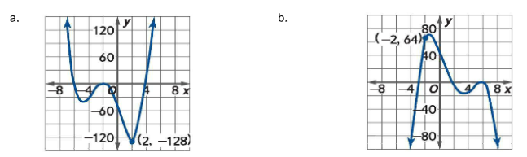

If 2 + 3i is one root of the polynomial x3 + ax2 + b = 0. Find all the other remaining root.

Find the equation of the given graph (challenge)

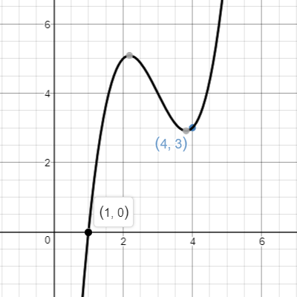

**https://ibmathsresources.com/2014/04/25/graphically-understanding-complex-roots/**

**Target 4 Assessment**

Factor, then solve the polynomial x5 – 3x3 +6x2 – 28x +24

Write a polynomial equation with the roots $x=2±3i$ and 5, that goes through point (4, 20). Sketch the graph, describe end behavior

If 3 + 2i is one root of the polynomial x3 + ax2 + b = 0. Find all the other remaining root.

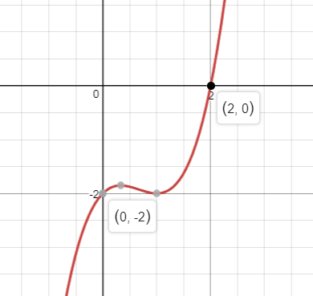

Find the equation of the given graph (challenge)